**Queen’s College 155 Anniversary Quiz**

1. Consider the number **39**.

The smallest prime and the biggest prime factor of 39 are 3 and 13.

The prime numbers between 3 and 13 are 3, 5, 7, 11, 13.

Also, **39** = 3 + 5 + 7 + 11 + 13.

Find the next number that has each property.

(Hint: the number is bigger than 100 and it must not be a prime number.)

**1 Ans.**  **155** =

**2.** The number of vertices of a right prism is greater than the number of vertices of a right pyramid by 1. If the pyramid has **155** faces, find the sum of the number of edges of the two solids.

**2 Ans.** Number of faces of the pyramid = 155

Number of **slant** **faces** of the pyramid = 154

Number of edges of all slant faces = 154

The base of the pyramid is a polygon of 154 sides and therefore has 154 edges.

Totol number of edges of the pyramid = 154 + 154 = **308**

Total number of vertices of the pyramid = 155

Therefore the total number of vertices of the prism = 156

The base and the top of the prism is a polygon of sides.

Number of edges of the of the prism =

Total number of edges of the two solids =

**3.**

There are 3 trailing zeros. (Continuous number of zeros in the right side of the number.)

How many trailing zeros are there in

**3 Ans.** A trailing zero is formed when a multiple of 5 is multiplied with a multiple of 2. Now all we have to do is count the number of 5’s and 2’s in the multiplication.

Since a zero is created by and there are more factors of 2 than 5 in , all we have to do is to count the factor 5 in the product.

Let’s count the 5’s first. 5, 10, 15, 20, 25 and so on, making a total , where denotes the largest integer smaller or equal to x.

However there are numbers 25, 50, 75, … which makes up two fives in each of them (, these number count up to

Similarly, we need to count up numbers which have 3 fives as factors.

Number of trailing zeros =

**4.** Simplify

**4 Ans.**

**5.** Find the **centre number** of the 155th row the Kordemsky’s triangular array. Find also the sum of all numbers in this row.

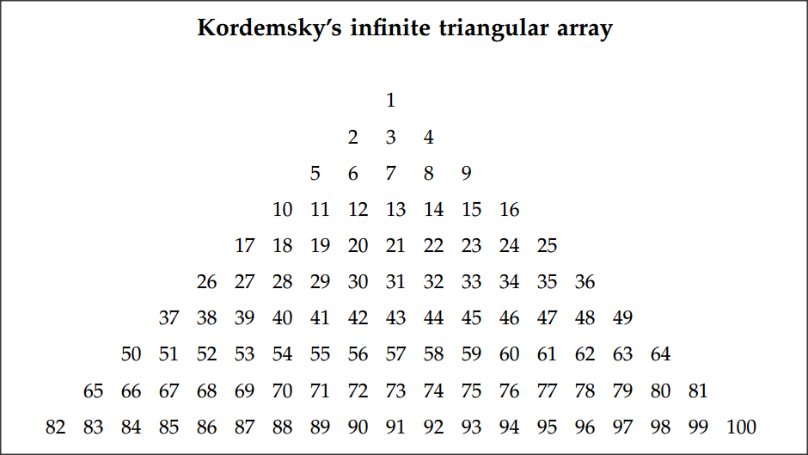

**5 Ans.** The last number of the nth row =

The centre number of the nth row =

The centre number of the 155th row =

There are (2n – 1) numbers in the rth row.

The first number in the nth row =

The first number in the 155th row =

Sum of all numbers in the 155th row =

**6.** If , find .

**6 Ans.**

Hence,

Replace x by ,

**7.** The sequence satisfies :

where k = 1, 2, …, 155,….

Find the integral part (that is, excluding the decimal part) of the sum

. (Hint: .)

**7 Ans.** We have

Similarly,

Work up to

Add all these identities up, we have

Since , we have

< (More serious reader may use mathematical induction.)

Then

The integral part of is **1**.

**16/4/2017**

**Yue Kwok Choy**